#### HANDS Dissemination

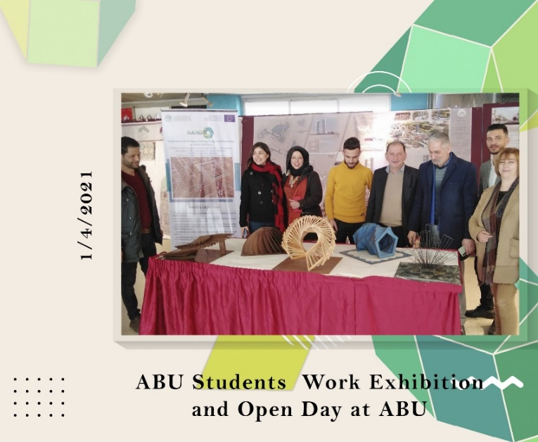**HANDS – Students Work Exhibition at ABU**

**WP 8: DISSEMINATION & EXPLOITATION**

**Date:** Thursday, 1/4/2021  
**Organizer:** AlBaath University of Syria, (ABU)   
**Location:** Faculty of Architecture

The HANDS project held a prominent exhibition during Al-Baath University's Student Day celebrations on April 1st, 2021. The exhibition showcased captivating work by third- and fourth-year students, underscoring the HANDS project's impact on fostering talent and innovation in traditional craftsmanship. This showcase served not only as a testament to HANDS' successes but also as a catalyst for future collaboration and inspiration within the university community.